**HOW TO EXPORT LANELET2, XODR AND PCD FILE**

After proper map annotation we can export map in a above formats in unity.

1. For Lanelet2 and XODR map:

Note: In lanelet2 map draw parking spot with the help of JOSM

Click on Export HD Map

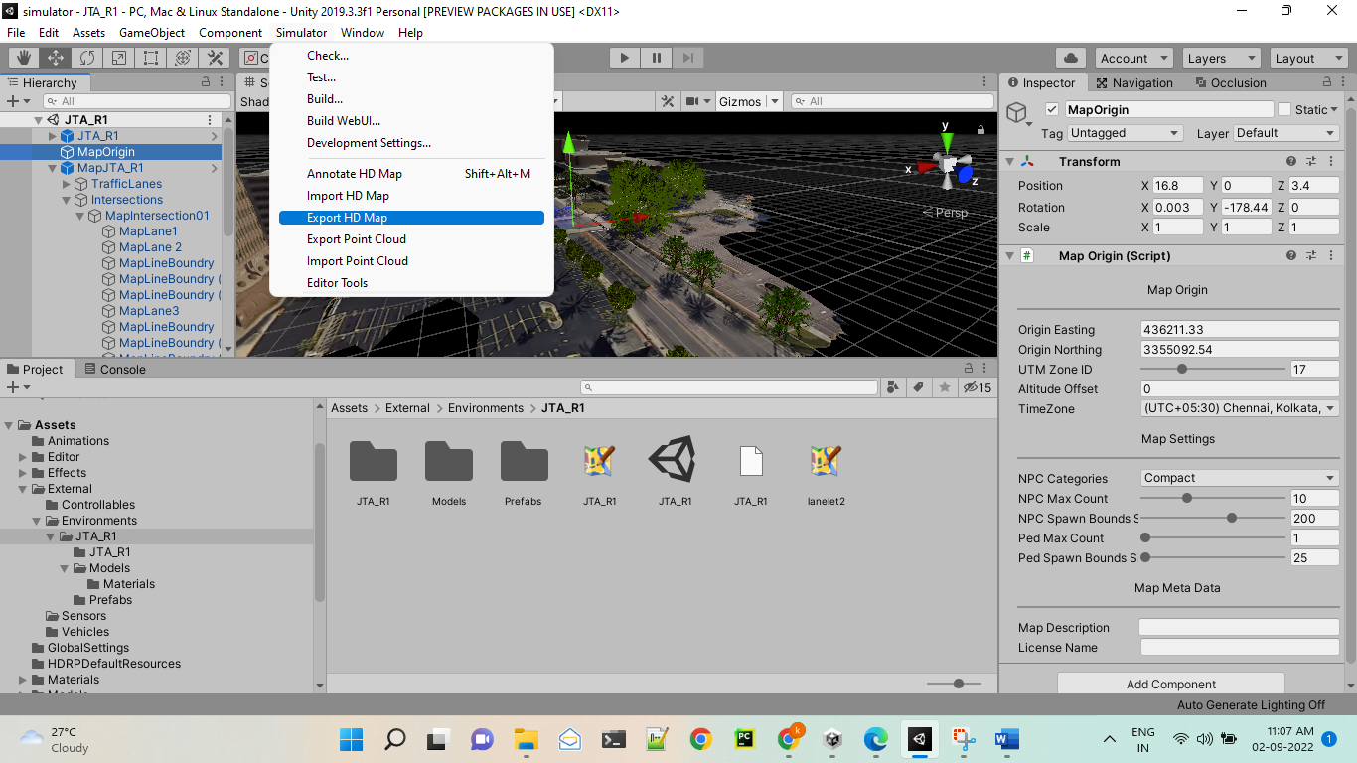

Click on whichever format you want to export

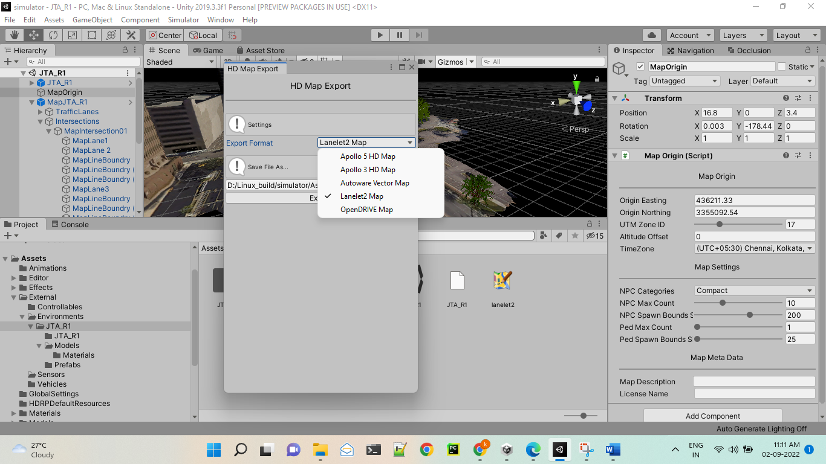

2. Export PCD file

For PCD you need Lidar sensor file in siumaltor/Assest/Sensor/Lidar

Refer this link -<https://www.svlsimulator.com/docs/simulation-content/pointcloud-export/>

After that click on export point cloud

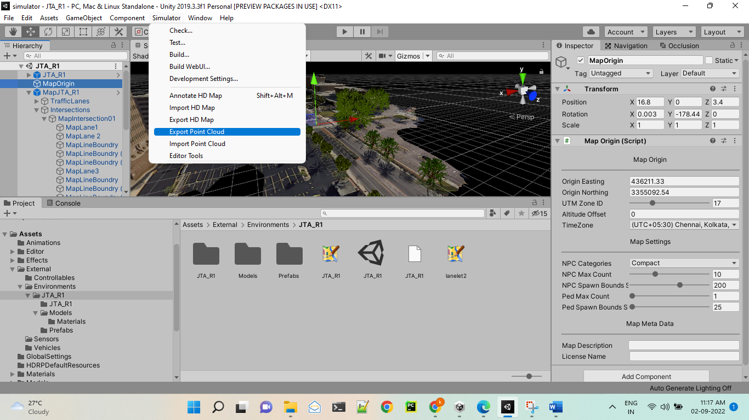

Note:

If this function showing error then use unity 2020.3.3f1 version .

Open same project in unity 2020.3.3f1 and follow same process of pcd exportation.